Syntax errors in code

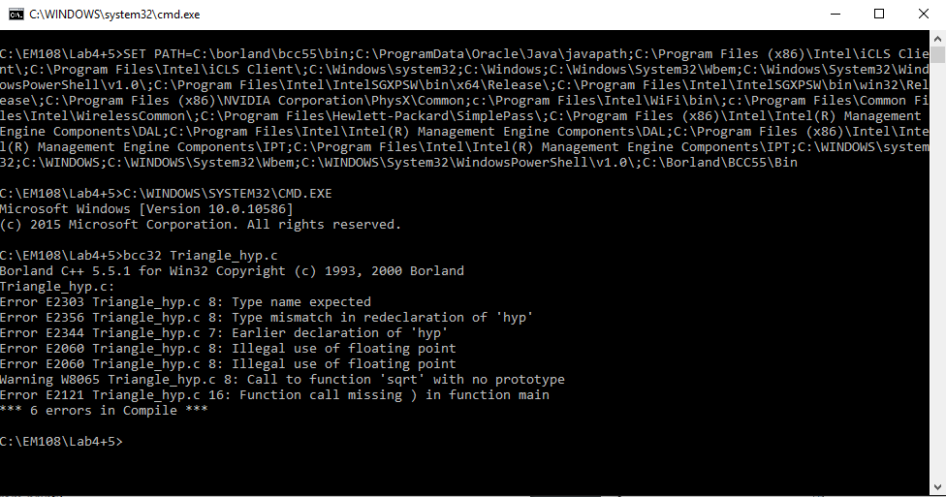

Incorrectly squared. Working correctly

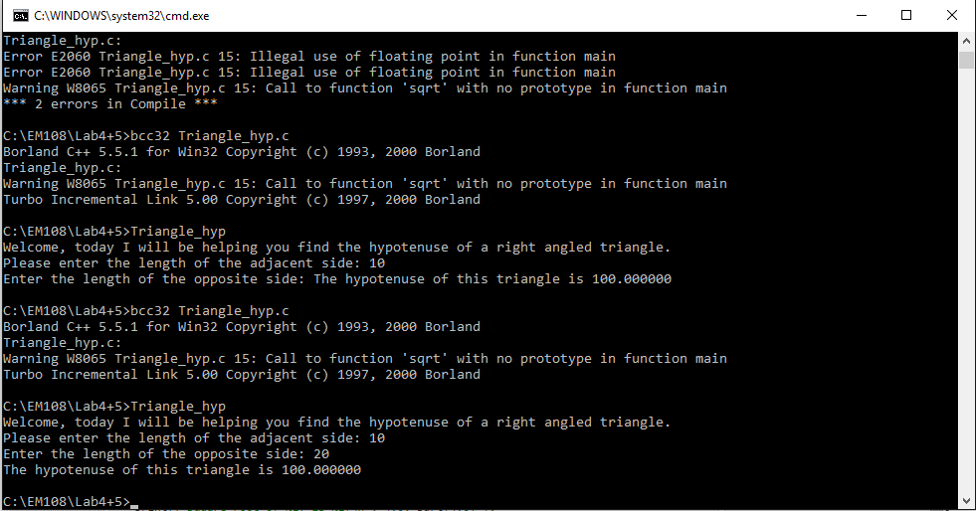

Errors.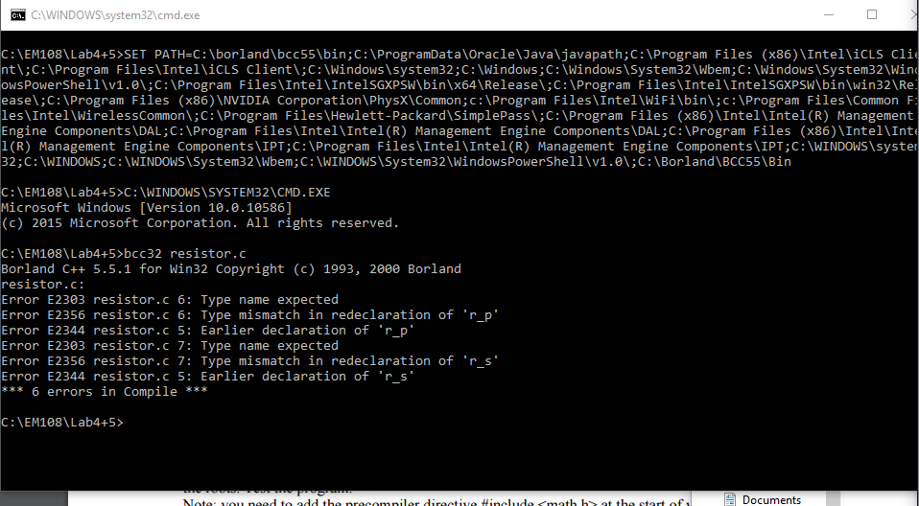

Definition of rp and rs included in the wrong place.

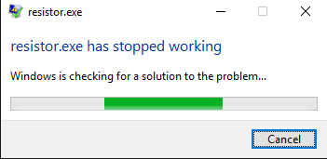

Error in maths is causing the programme to attempt to divide by zero.

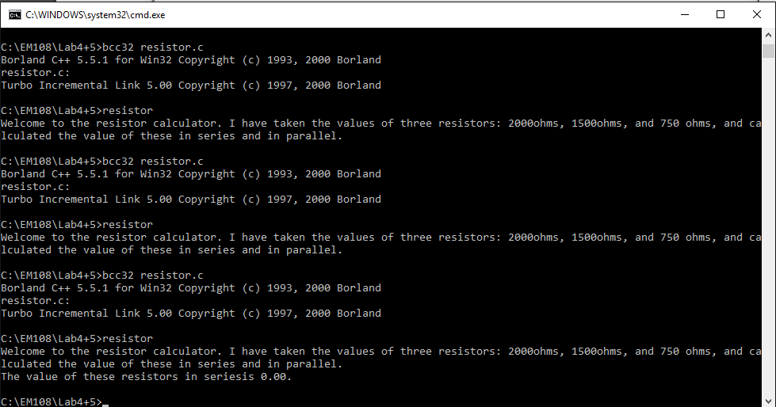

Resistors in series working

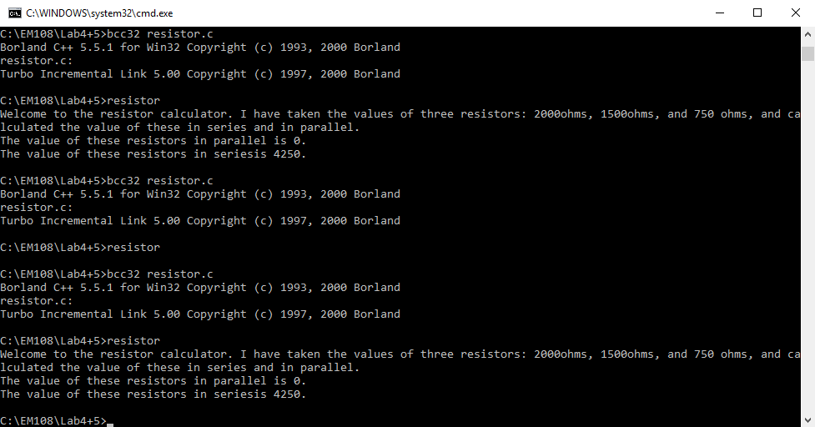

Parallel still not working, now not crashing.

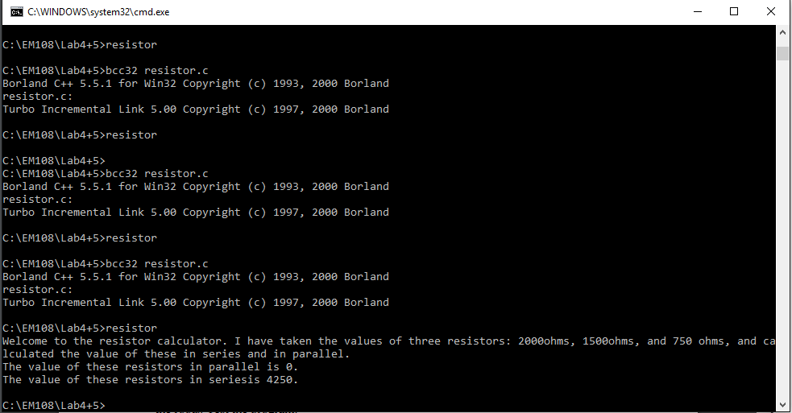

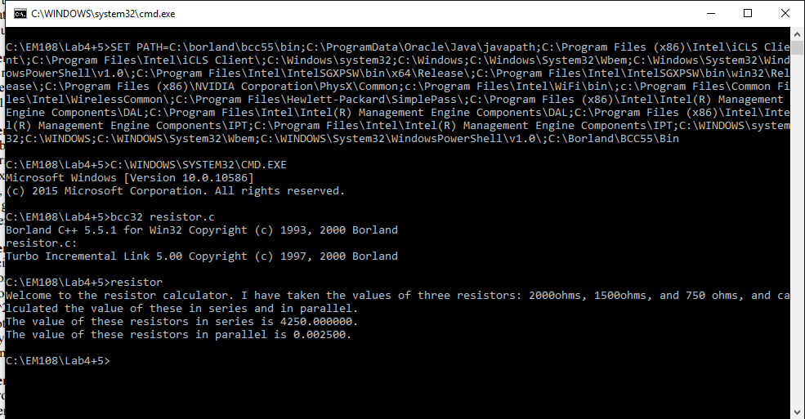

Variables declared as floats, prints value for rp, values are incorrect



Expression corrected, correct values print.



Correct value printed with single decimal place

Scanf is scanning twice.



Mistake in code (an extra scan function) was removed and text added.

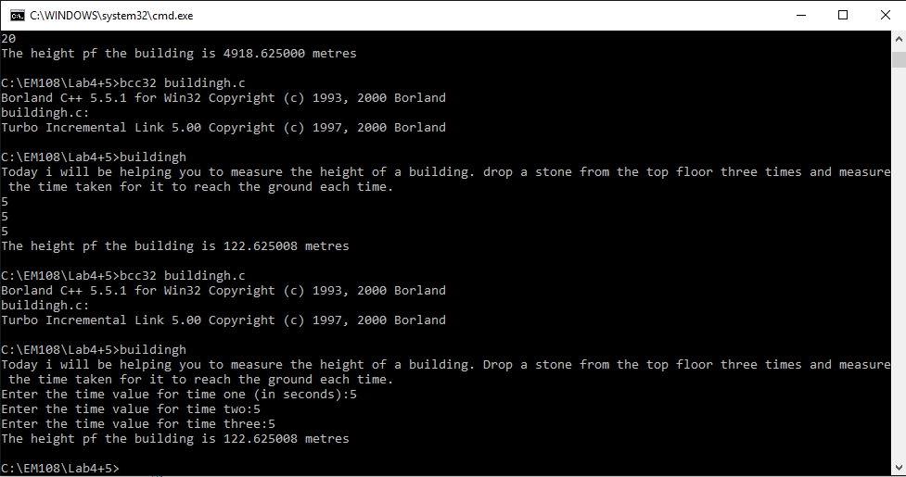

Spelling mistake fixed, decimal places added, tested.

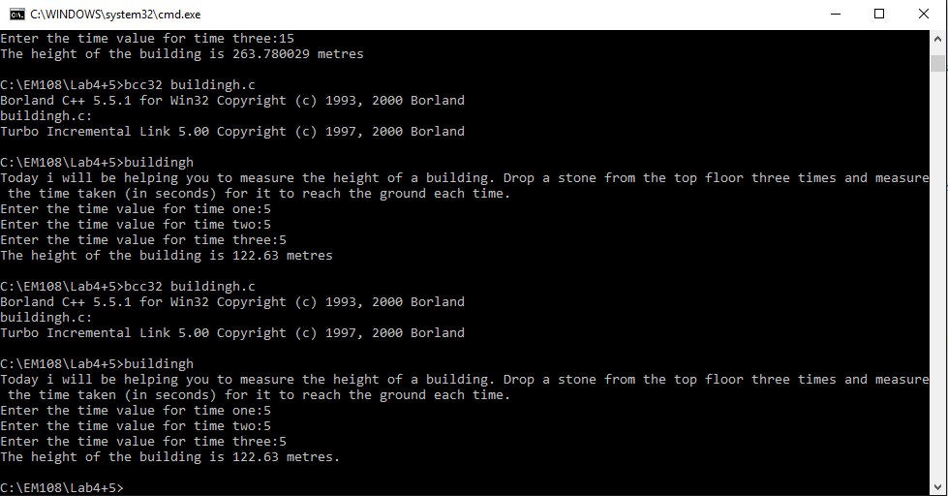

Initial code working but with scan function scanning twice

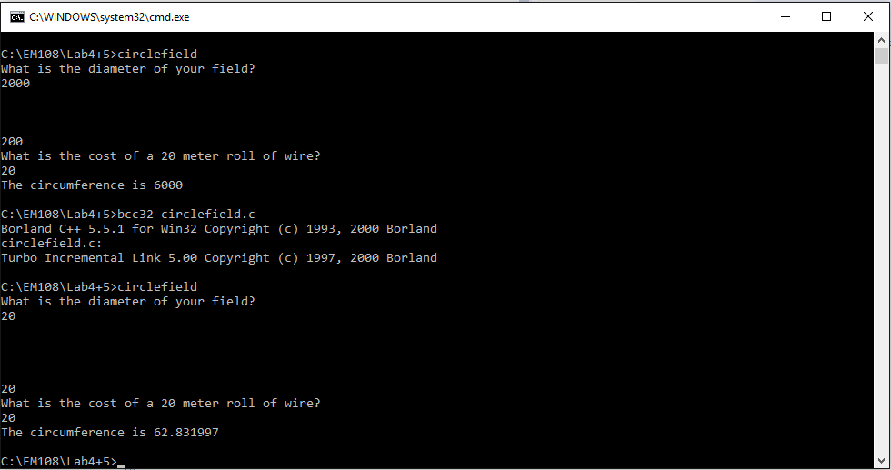

Code working correctly but with incorrect scan function.

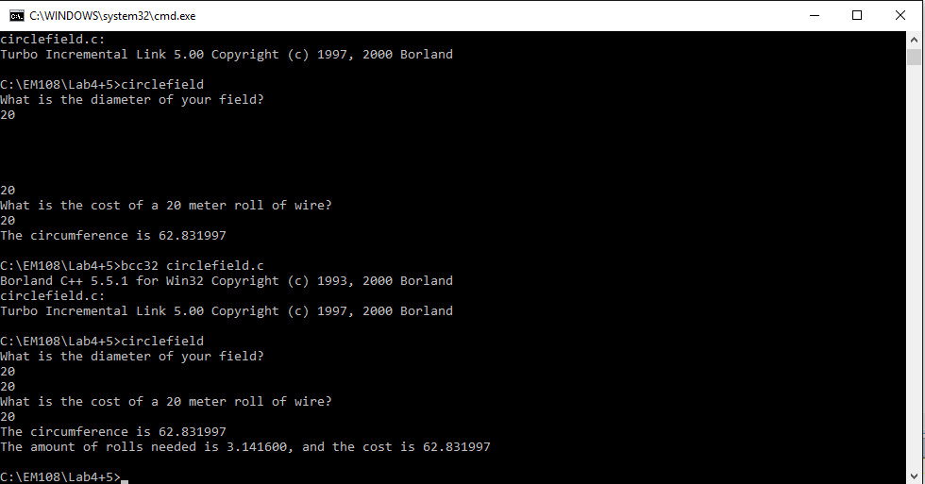

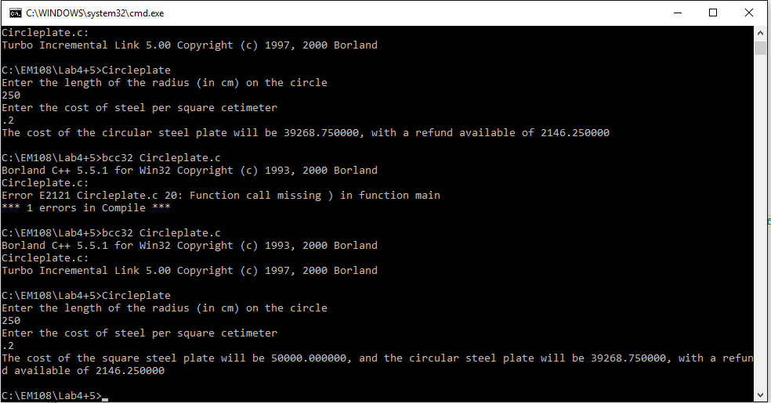

Steel plate was scanning incorrectly due to absence of & symbol. This was corrected along with errors in expressions.

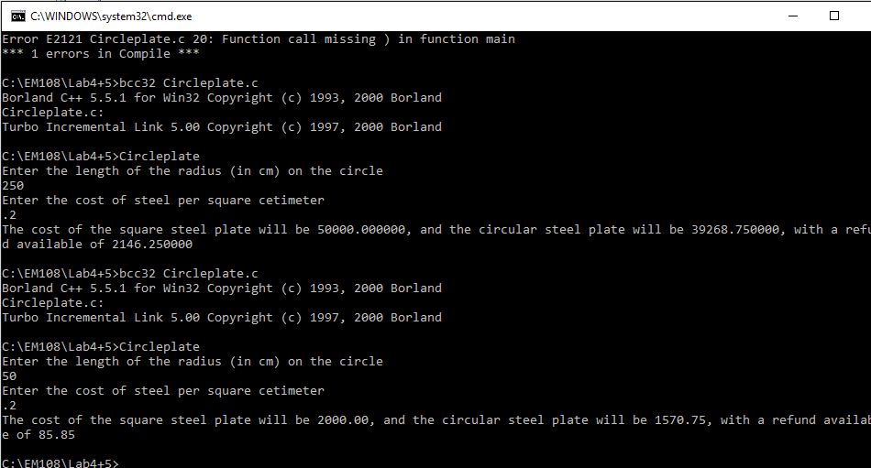

Decimal points added.